Revision History

|  |  |  |  |
| --- | --- | --- | --- |
| **Date** | **Version** | **Description** | **Author** |
| 22.03.2014 | 1.11 | Initial version of SDD | İsmetcan Hergünşen, Mehmet Kağan Kayaalp, Nazlı Karalar, Gamze Küçükçolak, Erdi Koç |
| 23.03.2014 | 1.12 | Introduction (References, abbreviations etc.) | Nazlı Karalar, Kağan Kayaalp |
| 24.03.2014 | 1.13 | Component 1 | Gamze Küçükçolak, Erdi Koç |
| 24.03.2014 | 1.13 | Component 2 | Mehmet Kağan Kayaalp, Nazlı Karalar, |
| 24.03.2014 | 1.13 | Component 3 | İsmetcan Hergünşen |
| 26.03.2014 | 1.15 |  |  |
| 27.03.2014 | 1.16 |  |  |
| 28.03.2014 | 1.17 |  |  |
| 29.03.2014 | 1.18 |  |  |
| 30.03.2014 | 1.19 |  |  |
| 31.03.2014 | 1.20 |  |  |
| 01.04.2014 | 1.21 |  |  |

**TABLE OF CONTENTS**

Revision History 1

1 Introduction 3

1.1 References 3

1.1.1 Project References 3

1.1.2 Abbreviations 3

2 Software Architecture overview 4

2.1 MVC Model 4

3 Software design description 4

3.1 Component 1 – Game Logic 5

3.1.1 Component interfaces 5

3.1.2 Component design description 5

3.1.3 Workflows and algorithms 8

3.1.4 Software requirements mapping 8

3.2 Component 2 – Game View 8

3.2.1 Component interfaces 8

3.2.2 Component design description 8

3.2.3 Workflows and algorithms 9

3.2.4 Software requirements mapping 11

3.3 Component 3 – Game Controller 11

3.3.1 Component interfaces 12

3.3.2 Component design description 12

3.3.3 Workflows and algorithms 12

3.3.4 Software requirements mapping 14

# Introduction

SDD is a representation of the software system design such as software components and interfaces. It also shows how the software system will be structured to satisfy the requirements. The purpose of SDD is to define the detailed design for all components of CCB system.

The SDD document is organized as follows. In the first part of SDD, it describes the project references and abbreviations and in component part, it shows the design of the system with UML diagrams.

## References

### Project References

| **#** | **Document Identifier** | **Document Title** |
| --- | --- | --- |
| DOC#SRS V1.0 | [1] | Software Requirement Specification |
| DOC#STP  V1.0 | [2] | Software Test Plan |

### Abbreviations

|  |  |
| --- | --- |
| **Term** | **Description** |
| CCB Project | Crazy Copter Battle Project Game |
| DOC #SDDv.1.0.x | Document version 1.0.x |
| JDA | Java Desktop Application |
| MVC | Model View Controller |
| UI | User Interface |
| GUI | Graphical User Interface |
| SDP | Software Development Plan |
| SRS | Software Requirements Document |
| UML | Unified Modeling Language |
| STP | Software Test Plan |
| JDK | Java Development Kit |
| SRS-CCB-XXX.X | Software Requirement Specification – CCB – XXX.X |
| STR | Software Test Report |

# Software Architecture overview

## Game Screen – Game Logic – Game Controller Model

This diagram shows basic operations of Game Screen – Game Logic – Game Controller model that will be used in CCB software system.

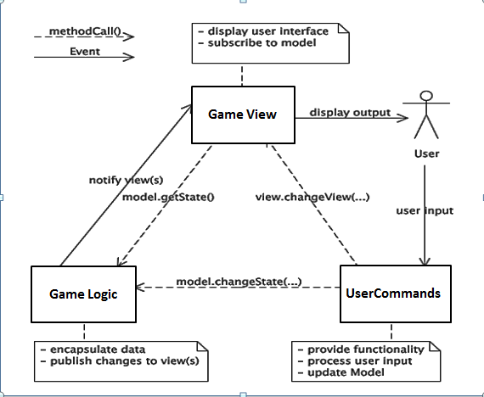

# Software design description

CCB software system will have one package and in package content, there will be several classes whose operations are divided depending on MVC model. Therefore, the components of CCB are Model, View and Controller.

A model notifies its associated views and controllers when there has been a change in its state. This notification allows views to update their presentation, and controllers to change the available set of instructions/commands (like pause).

A view is told by the controller all the information it needs for generating an output representation to the user. It will also provide generic mechanisms to inform the controller of the user input.

A controller will send commands to the model to update the model’s state. It will also send commands to its associated view to change the view’s presentation of the model.

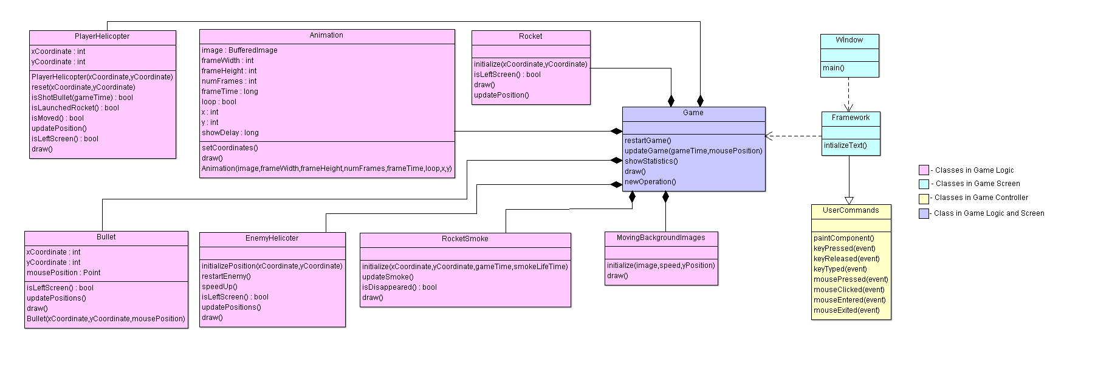

**(Game Screen – Game Logic – Game Controller Detailed Class Diagram)**

## Component 1 – Game Logic

### Component interfaces

Input: User will press the start button.

Output: Game will start. Images will be created.

### Component design description

Class: Animation

Constructor

-Usage: Initialize number of frames and set time between frames

Methods

* **public** **void** setCoordinates()
* **public** **void** draw()

Class: MovingBackgroundImages

Methods

* **public** **void** initialize()
* **public** **void** draw()

Class: Game

Constructor

-Usage: Initialize bullets, rockets, enemy helicopters etc.

Methods

* **public** **void** restartGame()
* **public** **void** updateGame()
* **public** **void** draw()
* **public** **void** showStatistics()

Class: PlayerHelicopter

Constructor

-Usage: Load parts of the helicopter images and create animation objects

Methods

* **public** **void** reset()
* **public** **boolean** isShotBullet ()
* **public** **boolean** isLaunchedRocket()
* **public** **boolean** isMoved()
* **public** **void** updatePosition()
* **public** **void** draw()
* **public boolean** isLeftScreen()

Class: EnemyHelicopter

Methods

* **public** **void** initializePosition()
* **public boolean** isLeftScreen()
* **public** **void** restartEnemy()
* **public** **void** speedUp()
* **public** **void** draw()
* **public** **void** updatePosition()

Class: Bullet

Constructor

-Usage: Initialize bullet position and speed.

Methods

* **public boolean** isLeftScreen()
* **public** **void** draw()
* **public** **void** updatePosition()

Class: Rocket

Constructor

-Usage: Initialize rocket position and speed.

Methods

* **public boolean** isLeftScreen()
* **public** **void** draw()
* **public** **void** updatePosition()

Class: RocketSmoke

Methods

* **public** **void** initialize()
* **public boolean** isDisappeared()
* **public** **void** draw()
* **public** **void** updateSmoke()

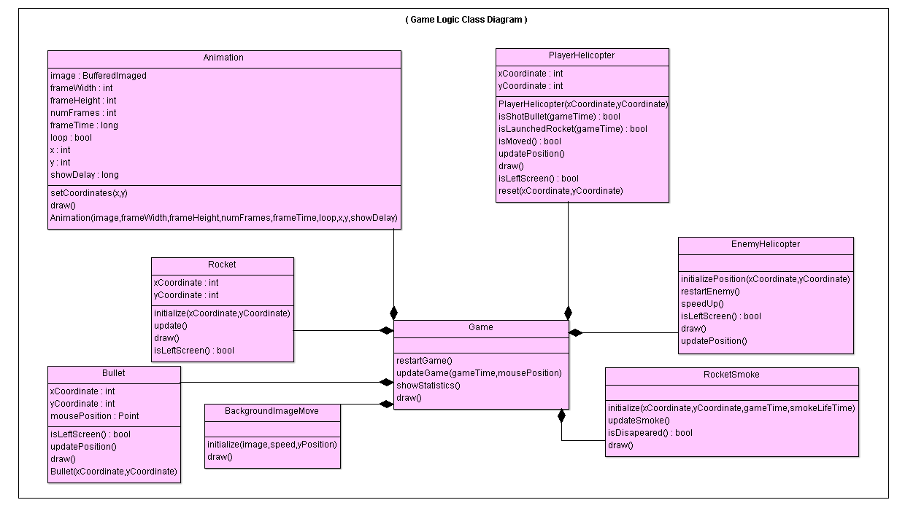

### Workflows and algorithms

(AŞAĞIDA Kİ TABLODA KENDİMİZİ ÇOK TEKRARLAMIŞIZ İLKİ KALACAK DİĞERLERİ SİLİNECEK. TABLONUN ALTINA “ŞUNLAR ŞUNLAR DA ŞURADA Kİ GİBİDİR” TARZI AÇIKLAMA YAZILACAK. AYIRCA EKSTREM BİR DURUM VARSA YANİ DEĞİŞİK BU TABLODA BELİRTMEDİĞİMİZ ONLARI DÜŞÜNELİM. ONLARI BELİRTELİM AMA KESİNLİKLE TABLO ŞEKLİNDE KENDİMİZİ TEKRAR ETMEYECEĞİZ. AYNI OLAY VARSA BİR TANESİNİ TABLODA GÖSTERİP GERİSİNİ TABLO ALTINDA AÇIKLAMA ŞEKLİNDE YAZALIM.)

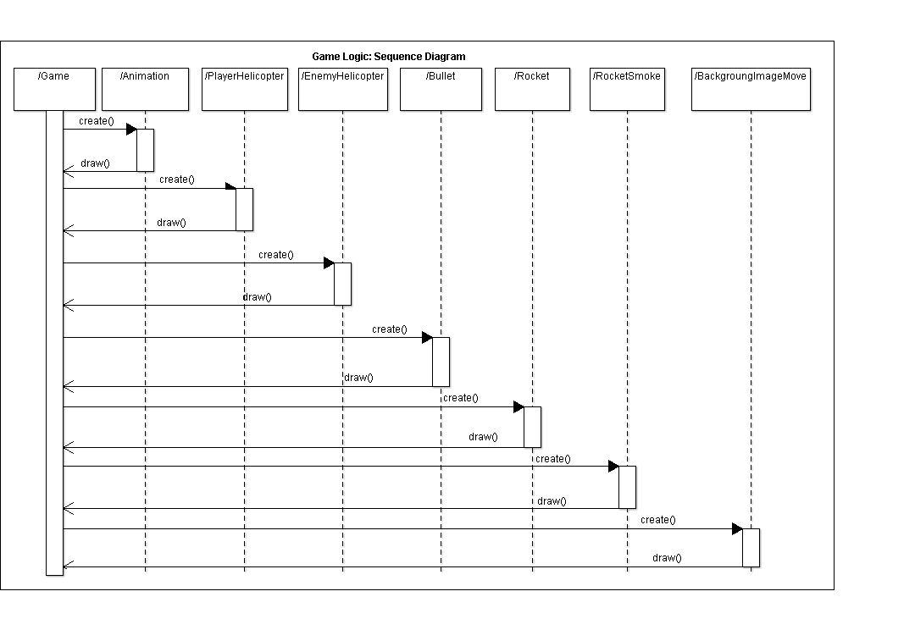

### Software requirements mapping

* SRS-CCB-003.1
* SRS-CCB-004.3
* SRS-CCB-007.1

## Component 2 – Game Screen

### Component interfaces

Input: User will open the game.

Output: Images (helicopters, background, bullets, rocket, collision) ,texts(statistics info, help info) will appear.

### Component design description

Class: Window

Constructor

-Usage: Create a new instance of this class

Methods

* Main

**public** **static** **void** main(String[] args)

Class: Framework

Constructor

-Usage: Initialize framework, background images etc.

Methods

* **public** **void** initializeText()
* **public** **void** keyReleased(KeyEvent event)
* **public** **void** mouseClicked(MouseEvent event)

Class: Game

Constructor

-Usage: Initialize all objects of the game such as bullets, helicopter, and create content of the game.

Methods

* **public** **void** restartGame()
* **public** **void** updateGame()
* **public** **void** draw()
* **public** **void** showStatistics()

*Class diagram for Component 2:*

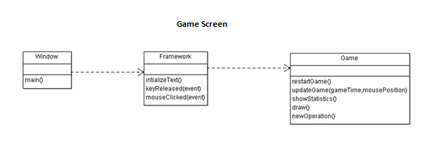

### Workflows and algorithms

*Sequence Diagrams for Component 2:*

* *Sequence Diagram–1:* When user starts the game, Window which includes the main method of the game will call Framework class and then Framework will create splash screen texts, images. In the main method, window class will be called in order to create the menu size, image, text etc.

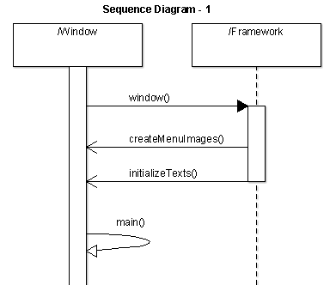

(YUKARIDA Kİ TABLODA KENDİMİZİ ÇOK TEKRARLAMIŞIZ **–Not: Clear ların çok olduğu tabloyu sildim, yerine sequence diagram – 3 ü yaptım, hem clear var hem de create-** İLKİ KALACAK DİĞERLERİ SİLİNECEK. TABLONUN ALTINA “ŞUNLAR ŞUNLAR DA ŞURADA Kİ GİBİDİR” TARZI AÇIKLAMA YAZILACAK. AYIRCA EKSTREM BİR DURUM VARSA YANİ DEĞİŞİK BU TABLODA BELİRTMEDİĞİMİZ ONLARI DÜŞÜNELİM. ONLARI BELİRTELİM AMA KESİNLİKLE TABLO ŞEKLİNDE KENDİMİZİ TEKRAR ETMEYECEĞİZ. AYNI OLAY VARSA BİR TANESİNİ TABLODA GÖSTERİP GERİSİNİ TABLO ALTINDA AÇIKLAMA ŞEKLİNDE YAZALIM.)

* *Sequence Diagram-2:* Framework class will create Game object in its one of the method, createGame, and methods of Game class can be reached by Framework.

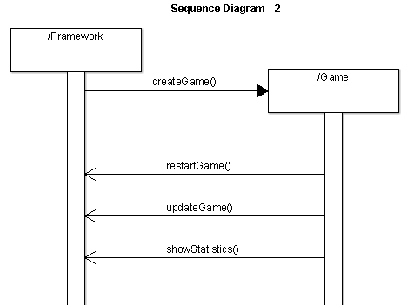

Böyle oldu mu peki? (YUKARIDA Kİ TABLODA OK’LARIN ANLAMLARINA DİKKAT EDİLMEMİŞ. KESİK OLANLARDA DÜZ ÇİZGİ OLACAK.)(YUKARIDAKİ METHODLARIMIZ BİZİM GENELİ VOİD OLDUĞU İÇİN RETURN İLE GÖSTERMEMELİYİZ EĞER PRİMİTİVE (İNT,STRİNG …) TYPE OLURSA METHOD GERİ RETURN ETMELİYİZ SADECE)

* *Sequence Diagram-3:* When the user restarts the game, player helicopter will be created and objects such as enemy helicopters, bullets, rockets etc. will be cleared.

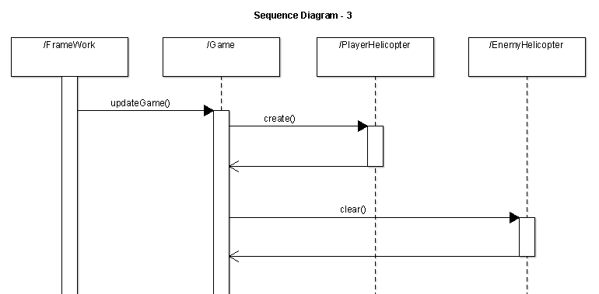

### Software requirements mapping

* SRS-CCB-001.1
* SRS-CCB-001.2
* SRS-CCB-002.1
* SRS-CCB-004.1
* SRS-CCB-004.2
* SRS-CCB-009.1
* SRS-CCB-009.2

## Component 3 – Game Controller

Game controller component includes all of the commands which user will use to play game.

ŞURAYADA KÜÇÜK BİR ACIKLMA EN FAZLA 2-3 SATIR BİRACIKLMA YAPMAK GEREKİYOR (Not: Devamı yok)

### Component interfaces

Input: User will press keys (“A, S, W, D” or arrows) and click (right, left) or move mouse.

Output: Helicopter will move and fire bullets or rockets and mouse cursor will move.

### Component design description

Class: Canvas

Constructor

-Usage: Create a mouse cursor and calls key and mouse listeners.

Methods

* **public** **void** paintComponent()
* **public** **void** keyPressed(KeyEvent event)
* **public** **void** keyReleased(KeyEvent event)
* **public** **void** keyTyped(KeyEvent event)
* **public** **void** mousePressed(MouseEvent event)
* **public** **void** mouseRelased(MouseEvent event)
* **public** **void** mouseClicked(MouseEvent event)
* **public** **void** mouseEntered(MouseEvent event)
* **public** **void** mouseExited(MouseEvent event)

(AŞAĞIDA Kİ TABLO ÇIKACAK YA DA BAŞKA BİR YERDE BİR BENZERİ KULLANILACAK. CONTROLLER’DA CANVAS OLMAYACAK.)(YANİ CANVASIN İSMİ DEĞİŞTİRLECEK CÜNKÜ CANVAS VİEW ANLAMINA GELİYRO BİR COK YERDE ONUN İÇİN İSMİN DEĞİŞTİRELİM MESELA COMMAND CLASS YA DA GAME CONTROLLER HER YERDE AYNI İSMİ KULLANMAMIZ GEREKİYOR UNUTMAYALIM)

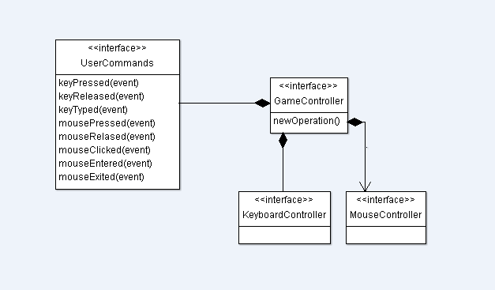

### Workflows and algorithms

BURAYA DA AŞAĞIDAKİ TABLOLARI ACIKLAYAN BİR DESCRİPTİONLAR SERPİŞTİRELİM :D :D

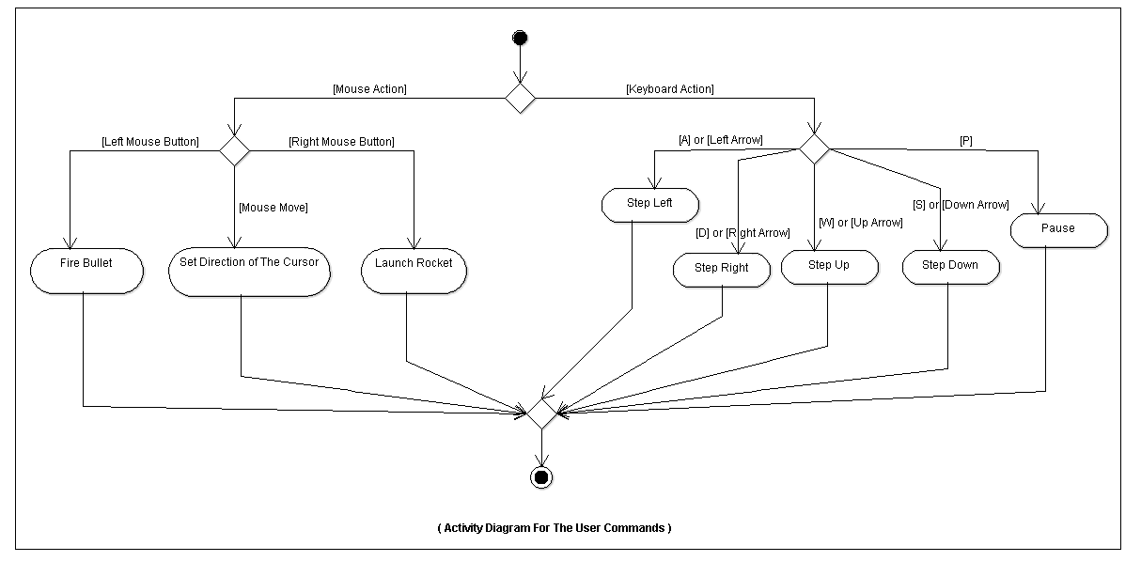

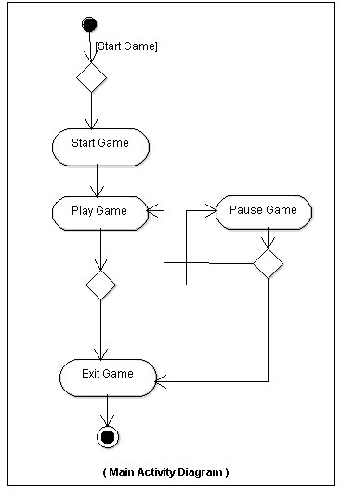

### Software requirements mapping

* SRS-CCB-001.3
* SRS-CCB-001.4
* SRS-CCB-005.1
* SRS-CCB-006.1
* SRS-CCB-006.2
* SRS-CCB-008.1